- RAM AND STORAGE THEORY

- Create a comparison table listing the main differences between DDR3, DDR4, and DDR5 RAM, including speed, voltage, and typical use cases.

- Introduction

RAM (Random Access Memory) is a vital component of a computer that temporarily stores data and instructions needed by the CPU. The performance of a computer depends greatly on the type and speed of RAM installed. Over the years, RAM technology has evolved from DDR3 to DDR4 and now DDR5, with each generation offering improvements in speed, efficiency, capacity, and overall system performance.

Comparison Table: DDR3 vs DDR4 vs DDR5 RAM
Feature | DDR3 RAM | DDR4 RAM | DDR5 RAM
Release Year | 2007 | 2014 | 2020
Speed Range | 800–2133 MT/s | 1600–3200 MT/s | 4800–8400+ MT/s
Voltage | 1.5V (1.35V for DDR3L) | 1.2V | 1.1V
Power Consumption | Higher | Lower than DDR3 | Lowest and most efficient
Bandwidth | Low | Medium | Very High
Maximum Capacity per Module | Up to 16 GB | Up to 64 GB | 128 GB and higher
Performance | Basic performance | Good performance | Excellent performance
Compatibility | Older systems | Modern systems | Latest systems
Cost | Lowest | Moderate | Highest
Typical Use Cases | Office PCs, web browsing, older computers | Gaming, multitasking, productivity | High-end gaming, AI, content creation, professional work

- Open your laptop or desktop (with power disconnected), locate the RAM slots, and take a clear photo of the installed RAM module. Reinstall the RAM module and verify that your system boots up successfully.
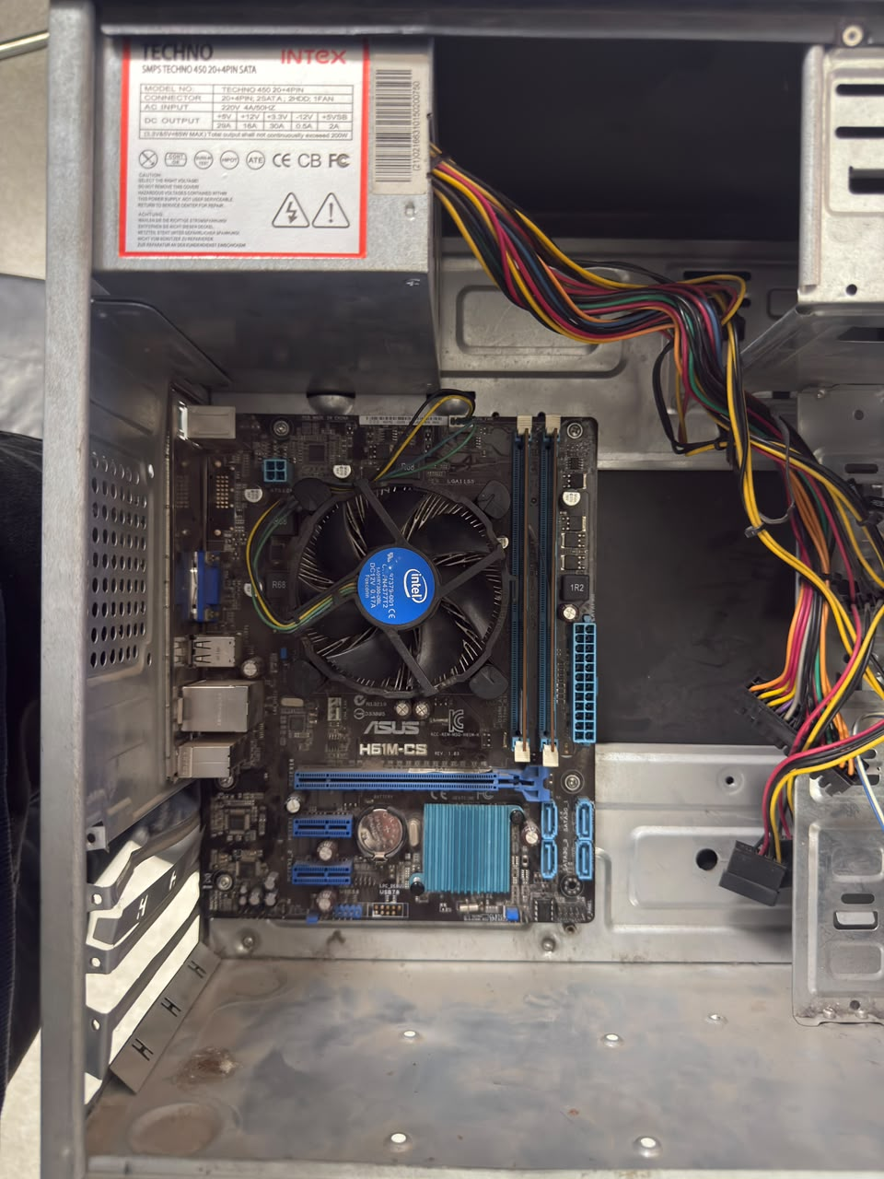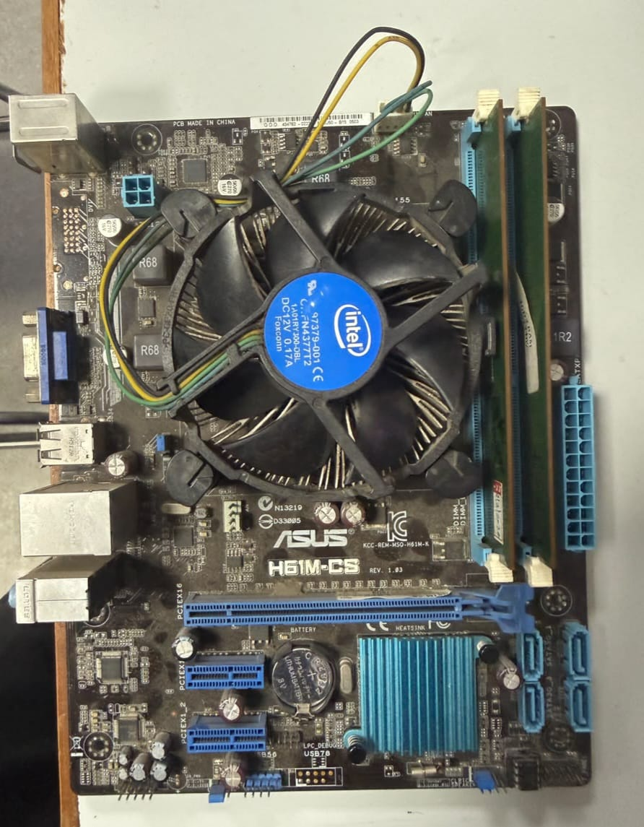

- Objective
To identify the installed RAM module in a computer, safely remove and reinstall it, and verify that the system boots successfully.
- Procedure
- Shut down the computer completely.
- Disconnect the power cable and any connected peripherals.
- Open the computer case (desktop) or RAM access panel (laptop) according to the device manual.
- Locate the RAM slot(s) and identify the installed RAM module.
- Take a clear photograph of the RAM module installed in the system.
- Carefully release the retaining clips on both sides of the RAM slot.
- Remove the RAM module gently.
- Reinstall the RAM module by aligning the notch correctly and pressing it firmly until the retaining clips lock into place.
- Close the case or panel and reconnect the power cable.
- Start the computer and verify that it boots normally.
Observation
- The RAM module was successfully identified and photographed.
- The RAM module was removed and reinstalled correctly.
- The system powered on and booted into the operating system without any errors.
- Result
The RAM module was successfully reinstalled, and the computer booted normally, confirming that the RAM was seated correctly and functioning properly.

- List three key differences between HDD, SSD, and NVMe storage types, and for each, name one app or use case (from apps you use daily) that would benefit most from that storage type.
- Introduction
Storage devices are used to store the operating system, applications, and personal files on a computer. The three most common storage technologies today are HDD (Hard Disk Drive), SSD (Solid State Drive), and NVMe SSD (Non-Volatile Memory Express SSD). Each offers different levels of speed, performance, and cost, making them suitable for different purposes.
- Comparison Table
Feature | HDD | SSD | NVMe SSD
Technology | Uses spinning magnetic disks | Uses flash memory chips | Uses flash memory and PCIe interface
Speed | Slowest | Faster than HDD | Fastest storage type
Cost per GB | Cheapest | Moderate | Most expensive
Durability | Less durable due to moving parts | More durable | Most durable and reliable
Boot Time | 30–60 seconds | 10–20 seconds | 5–10 seconds
Best For | Large file storage | Everyday computing | High-performance tasks

- Three Key Differences
1. Speed
- HDD: Slow read and write speeds because data is accessed from spinning disks.
- SSD: Much faster since there are no moving parts.
- NVMe SSD: Extremely fast because it communicates directly through the PCIe interface.
2. Durability
- HDD: More likely to be damaged by drops or shocks.
- SSD: More resistant to physical damage.
- NVMe SSD: Similar durability to SSD with enhanced reliability.
3. Cost and Performance
- HDD: Lowest cost but lowest performance.
- SSD: Good balance of price and performance.
- NVMe SSD: Highest performance but also the highest cost.

Daily Apps and Use Cases
Storage Type | Daily App / Use Case | Benefit
HDD | Storing Movies, Photos, and Music Collections | Large storage capacity at a low cost
SSD | Google Chrome, Microsoft Word, Zoom | Faster startup and smoother everyday use
NVMe SSD | Adobe Premiere Pro, Photoshop, Modern Games (GTA V, Valorant, COD) | Very fast loading, file transfers, and processing

- Conclusion
HDDs are best for storing large amounts of data at a low cost, SSDs provide a great balance of speed and affordability for everyday computing, and NVMe SSDs offer the highest performance for gaming, video editing, and professional workloads. Most modern laptops, including systems like the Lenovo IdeaPad Slim 3, use SSD or NVMe SSD storage to ensure fast boot times and smooth performance.

- Remove the storage drive (HDD or SSD) from your system, take a photo of the connector type (SATA, M.2, or NVMe), and reinstall the drive. Confirm that your device recognizes the storage after reassembly.
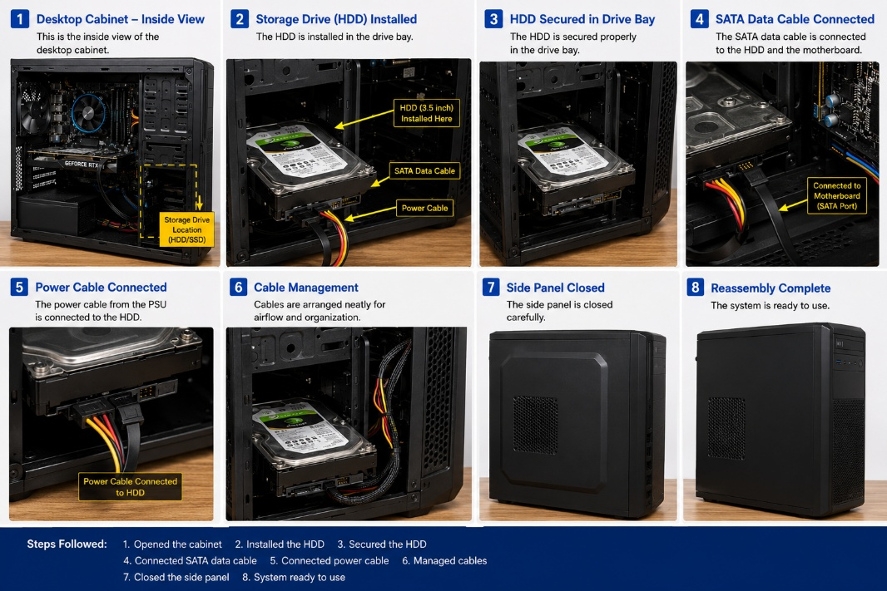
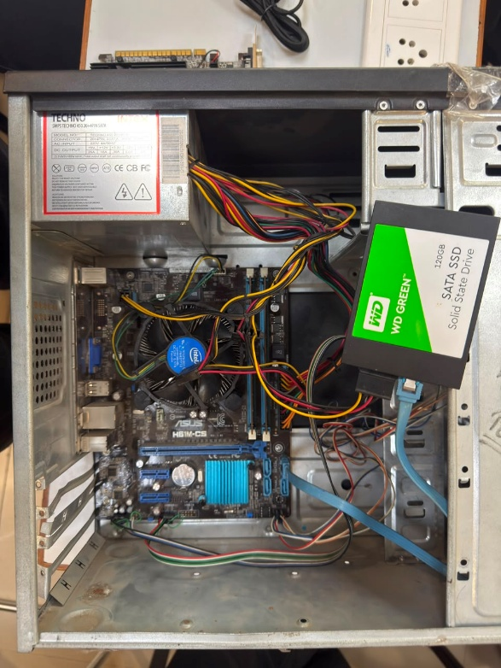

- Objective
To identify the storage drive connector type, safely remove and reinstall the storage device, and verify that the system recognizes the drive after reassembly.

- Procedure
- Shut down the laptop completely.
- Disconnect the charger and any external devices.
- Open the back cover according to the manufacturer's instructions.
- Locate the storage drive.
- Identify the connector type (SATA, M.2 SATA, or M.2 NVMe).
- Take a clear photograph of the storage drive and connector.
- Carefully remove the retaining screw and disconnect the drive.
- Reinstall the drive and secure it with the screw.
- Reassemble the laptop and reconnect power.
- Boot the system and verify that the storage drive is detected.

- Observation
- Storage drive type identified: M.2 NVMe SSD (verify on your device).
- Drive was removed and reinstalled successfully.
- System booted normally after reassembly.
- Storage capacity was recognized by Windows.

- Verification
After restarting the laptop:
- Storage detected by Windows: Yes
- Total Storage Capacity: 477 GB
- Operating System Booted Successfully: Yes

  - Result
The storage drive was successfully reinstalled, and the system recognized the drive without any errors.

